**DAILY ONLINE ACTIVITIES SUMMARY**

|  |  |  |  |  |  |  |  |  |
| --- | --- | --- | --- | --- | --- | --- | --- | --- |
| **Date:** | **14/06/2020** | | | | | **Name:** | **POOJA D S** | |
| **Sem & Sec** | **4th Sem 'B' Section** | | | | | **USN:** | **4AL18CS056** | |
| **Online Test Summary** | | | | | | | | |
| **Subject** | | **.....** | | | | | | |
| **Max. Marks** | | **30** | | **Score** | | | **…..** | |
| **Certification Course Summary** | | | | | | | | |
| **Course** | **Introduction to Ethical Hacking** | | | | | | | |
| **Certificate Provider** | | | **Great Learning Academy** | | **Duration** | | | **4.0 hour** |
| **Coding Challenges** | | | | | | | | |
| **Problem Statement:** A user will input two strings, and we find if one of the strings is a sub sequence of the other. Program prints “yes” if either the first string is a sub sequence of the second string or the second string is a sub sequence of the first string. Assume that, the length of the first string is smaller than or equal to the length of the second string. Assume that, the length of the first string is smaller than or equal to the length of the second string. | | | | | | | | |
| **Status: completed** | | | | | | | | |
| **Uploaded the report in Github** | | | | | **yes** | | | |
| **If yes Repository name** | | | | | <https://github.com/dspooja/C-coding> | | | |
| **Uploaded the report in slack** | | | | | **yes** | | | |

Online Test Details: (Attach the snapshot and briefly write the report for the same)

Certification Course Details: (Attach the snapshot and briefly write the report for the same)

Coding Challenges Details: (Attach the snapshot and briefly write the report for the same)

CERTIFICATION COURSE DETAILS:

* My Certification Course is **Introduction to Ethical Hacking.**
* **The concepts covered in Introduction to Ethical Hacking are:**
* Ethical Hacking in web Applications-Demonstration
* Ethical Hacking on Mobile Platform-Demonstration

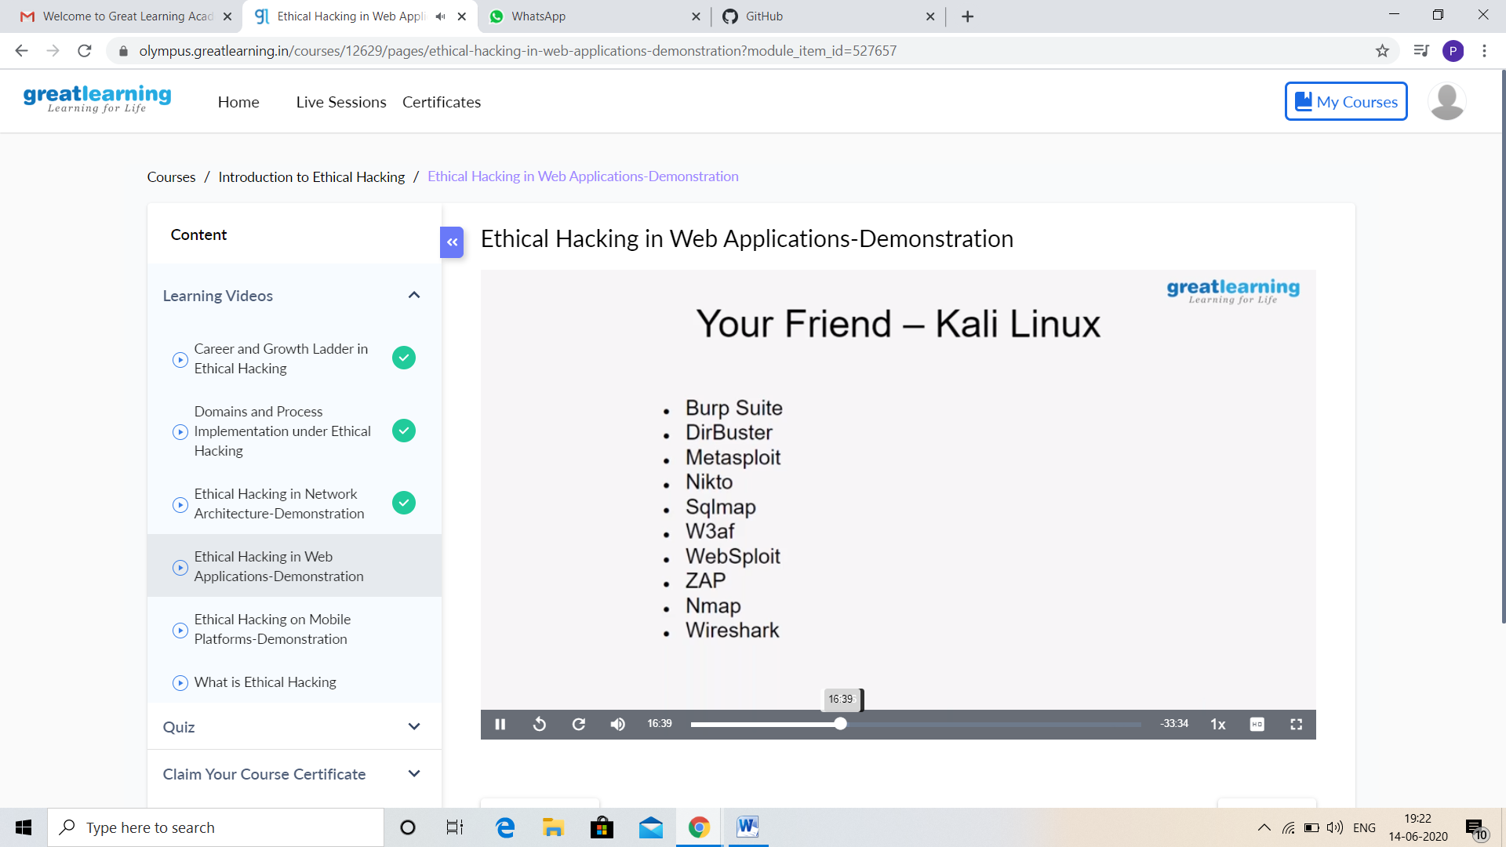

CODING CHALLENGES DETAILS:

Problem statement 1:

Write a C program to remove specific characters in the String

Example  
If the original string is "Welcome to AIET" and the user inputs string to remove "co" then the it should print "Welcome to AIET" as output.

**Input:**   
First line read a string  
Second line read key character to be removed.

**Output:**   
String which doesn't contain key character.

Solution: Uploaded in github.

